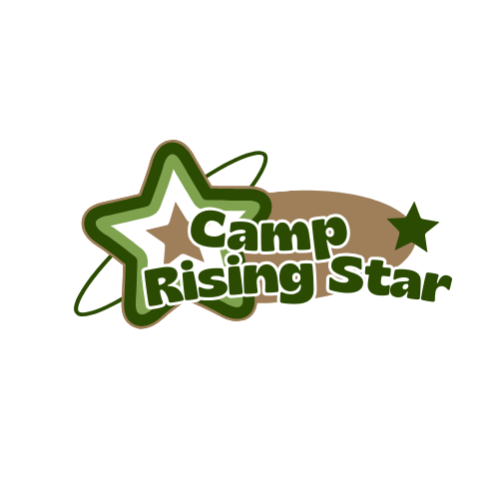
Camp Rising Stars
Summer Camp

JUNE/JULY
Out to Eat Week | June 23 | 24 | 25 | 26  Chick-Fil-A  Field Trip | 27
Winter Wonderland Week | 30 | July 1  Water Play | 2 | 3 | 4th  Center Closed
Animals Week | 7 | 8 | 9  Laurel Acres Park - | 10 | 11
Desert Week | 14  Cinemark Movies: Prince of Egypt | 15 | 16  Water Play | 17 | 18
Sports Week | 21 | 22  Pleasant Valley Mini Golf- tentative | 23 | 24 | 25
Up in Space Week | 28 | 29 | 30  Glow Bowling | 31  Water Play | August 1

AUGUST
Circus Week | 4 | 5 | 6 | 7  Bouncy House | 8
Camping Week | 11  Water Play | 12 | 13 | 14  Hiking Obstacle Course | 15
Farm & Garden Week | 18 | 19 | 20  Johnson’s Farm Trip | 21 | 22  Water Play
Travel Week | 25 | 26 | 27 | 27  Center Closed | 28  Center Closed

